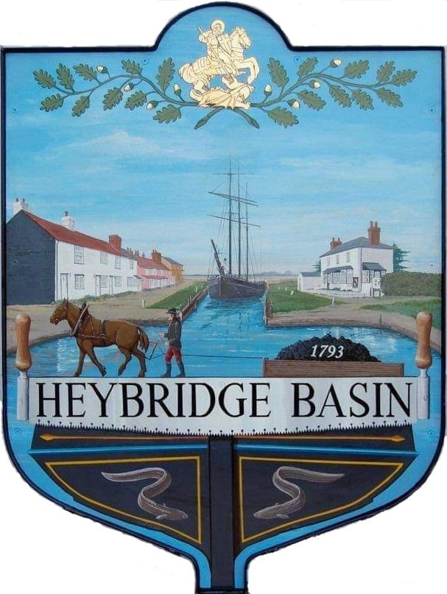

HEYBRIDGE BASIN PARISH COUNCIL

Minutes of the Full Council meeting of Heybridge Basin Parish Council held on Tuesday 12th March 2024 at 06.30pm, at The Lock Tearoom.

PRESENT

In the Chair: M. Hodges (Chair) Absent: 0

Councillors: R. Bryson Apologies: 1
C. Edmond
M. Hobden Public: 2
J. Sjollema
G. Howat District Councillors: 2

Officers: G. Lake – Clerk

It was noted that this meeting was being recorded by the Clerk.

23/201 Chair’s Welcome
Cllr Hodges welcomed everyone to the meeting and informed everyone that the Council held the first St Peters Consultation Councillor Surgery on Friday 8th March with the second being held on Friday 15th March. On Thursday 22nd February at All Saints to welcome Heather Atkinson, our new Minister. 38 Bird Boxes were made and delivered.

23/202 Apologies for Absence.
Cllr Swann.

23/203 To receive Declarations of Interest in accordance with the Council’s Code of Conduct and with section 106 of the Local Government Finance Act 1992.
C. Edmond – Non-Pecuniary – Essex Waterways and Director of Cloughton Court Management Company Ltd and Cllr Hobden – Non-Pecuniary – HBSA, Basin Oars and HB River care and Cllr Howat – Non-Pecuniary - HBCSA

23/204 To sign as a correct record the minutes of the full council meeting held on 13th February 2024.
The Minutes as previously circulated were agreed as a correct record.

23/205 To sign as a correct record the minutes of the extraordinary meeting held on 4th March 2024.
The Minutes as previously circulated were agreed as a correct record.

23/206 To receive a report from the District and County Councillors for the area on any matters of interest.
A report was received from the District Councillors. There were no reports from County Councillors.

23/207 Finance.
- To approve
- Payment requests for February/March 2024
The Payments as previously circulated were approved.
- Receipts for February/March 2024
The receipts as previously circulated were approved.

23/208 Asset Register
  - To review the Asset Register and agree any action to be taken.
The amendments to the Asset Register were approved.

23/209 Public Forum
1 member of public raised the following:

- The defibrillators had recently been used twice with both boxes being severely damaged resulting in a total cost of £1,380.00.
Would the Council be able to donate £200 towards this cost?
Could the Council circulate the new defibrillator information on their next newsletter?
The member of public was advised to email the Clerk with the wording they would like circulated, and that a donation application form would be sent to them.

- Is there an update on the on-street parking petition?
Cllr Hodges advised that there was not an update at this stage, however petition responses were low.

- Were the any updates on the village getting 20mph signs?
Cllr Sjollema advised conversations were taking place with Cllr Durham, and advised an update would be available soon. The Council are part of the 20’s plenty campaign.

23/210 Planning Applications
- To consider any planning applications received after the publication of the agenda and to agree the action to be taken.
There were no planning applications.

23/211 Biodiversity Policy
- To review the NALC Model Biodiversity Policy and agree any action to be taken.
It was resolved to adopt the NALC Model Biodiversity policy, and for Cllr Hobden to email the Clerk the proposed additions/amendments for review.

23/212 Daisy Meadow Car Park (DMCP)
- To receive an update from the Working Group and agree any action to be taken.
Cllr Hobden has been drafting a planting plan. It was resolved for Cllr Hobden and members of the HBSA and other volunteers to de-weed the raised bed area, and for the planting plan to be reviewed at the next meeting.
It was resolved for the Clerk to liaise with Petro Designs Ltd for a quote to return to Rohan House, if necessary.
It was resolved to remove the concrete path, clear the soil piles, remove the front fencing and replace the back fencing within the old toilet block area.
- To receive fencing quotations and revised access road tenders with additional information.
Fencing quotations and revised access road tenders with additional information were received.
- To consider and discuss the access road works and agree any action to be taken.
Discussions took place regarding the access road works. It was resolved to select Camway Group for both the road and fencing work. It was resolved for the Clerk to negotiate the price if possible. It was resolved for the Clerk to create public notices, letter drop and put a notice of works in the media.

23/213 D-Day 80
- To receive an update from the Working Group and agree any action to be taken.
A report had previously been circulated. It was resolved to purchase the materials required for the keyrings and cotton reel tank game at a cost of £34.32. It was resolved to donate £50.00 to the Regatta Committee for the use of their PA System. It was resolved for the Clerk to contact Paul regarding permission to use the land on the Lock Side as well as electricity for the PA System.

23/214 Nature Competition
- To consider a proposal from Cllr Hodges and agree any action to be taken.
It was resolved to accept the Nature Competition proposal, with the judging taking place on Regatta Day. It was resolved to purchase two £20.00 Amazon gift cards for prizes.

23/215 Village Design Statement (VDS)
- To review the VDS questionnaire and agree any action to be taken.
The VDS questionnaire was approved with the suggested amendments. It was resolved to get costings of printing as an allocated budget had previously been agreed during budget discussions. It was resolved for the Clerk to research quotes for online survey platforms.

23/216 St Georges Pedestrian Sign
- To receive an update from Cllrs Hodges and Howat and agree any action to be taken.
Cllr Hodges advised members of two quotations; however, it was resolved for Cllr Bryson to liaise with a resident who may be able to assist.

23/217 Streetlights
- To receive an update from Cllr Howat and agree any action to be taken.
Cllr Howat reported that several residents had commented on the new LED streetlights. The Clerk confirmed that Essex Highways and changes the streetlights they were responsible for and that the 13 the Council are responsible for had not been changed.

23/218 Heritage Trust
- To consider and agree for Cllr Howat to complete a survey being circulated by the Heritage Trust Network on behalf of the PC.
Cllr Howat advised that due to the deadline, the survey had been completed, and it was for an update on information that had previously been submitted.

23/219 Hedges along Basin Road
- To discuss the Hedges along Basin Road and agree any action to be taken.
It was confirmed that the Hedges had been cut, and the Council would review in September.

23/220 Clerks Report
- Statutory Meeting Date – It was resolved to move the statutory meeting to Monday 20th May 2024.
- Annual Parish Meeting – Clerk advised that the APM was booked in for Tuesday 23rd April 2024 and that the Lock tearoom have agreed to stay open to serve refreshments. A list of organisations to invite were discussed.

23/221 Correspondence
- To note correspondence received and any actions to be taken.
Correspondence was noted and responses were agreed.

There being no further business the meeting closed at 08:21pm
Provisional Date of the next Council Meeting Tuesday 23rd April 2024

Clerk Contact details: clerk@heybridgebasinpc.org.uk
Website: www.heybridgebasin-pc.gov.uk

